SCHOOL INTERVIEW/DISCUSSION GUIDE

Name of school: NABWEYO SSS

1a | Does the Facility have a record of all assets provided under UgIFT.  (Obtain a record and verify if it has the costs and numbers supplied | - YES
1b | If Not ask how many were supplied and when.

2 | How does this facility Maintain (repair/service/replace) the assets provided under Ugift  - It is maintained by the facility officials in charge using part of the PTA and Capitation grant

3 | Does the facility take regular record about functionality/ or breakdown of the assets provided?  Nonfunctional/ working, and reasons for non-functionality.  Most assets are functioning and others are not.  The following are the non-functional assets:  - Printer  It is well installed and was initially functioning well but according to Nabweyo sss secretary, the printer suddenly stopped working. The printer details are below  Serial No. PHM5P18529  product No. 2Z609A  Regulatory Model Number SHNGC-1800-00  - Projector  It is well installed and was initially functioning well but according to Nabweyo sss secretary, the printer suddenly stopped working  REASONS FOR NON-FUNCTIONALITY  - Theft of school property due to lack of a fence  - Unreliable electricity  Some equipment we received are substandard for examples the projector, and the printer | YES.  The facility records the functionality of the assets.

4 | How has the UgIFT support helped in service delivery in the area, any issues, challenges and any recommendations for better program implementation.  ISSUES/CHALLENGES  (Reported to us By Nabweyo sss head teacher. Nandala Milton Chris)  - High teacher to student ratio with the facility having 967 learners. This hinders the implementation of the competency based curriculum.  - Water connection. The head teacher reported that the water connection to the science laboratory is no longer working and there is no water in the science lab.  - Inadequate classrooms. Class rooms are very few compared to number of learners 967  - Inadequate teachers. Teaching staff is insufficient at the facility  - Safety at school. The school is always facing the challenge of school property mainly because if lack of fence  - Inadequate furniture  - Inadequate textbooks  - Inadequate staff quarters  - No physics equipment were provided  - Some of the door locks are not functioning  - Limited number of teachers(23 teachers only which is not proportional to the 967 learners)  - Inadequate classrooms. There are over 100 learners in a one class.  - The school has only one power meter serving the entire facility and this makes the usage of bought power units unmanageable  RECOMMENDATIONS  - Fence the facility  - Add More furniture at the facility  - Provide physics equipment  - Put sub meters in place  - Deploy more teachers  - A reliable water source is needed at the facility  - More text books  - School kitchen is needed

PROCEED TO VERIFICATION AFTER THIS DISCUSSION

SCHOOL FURNITURE
(School Desks, Office chairs, Laboratory stools, Book shelves)

Name of LG: NAMUTUMBA DISTRICT
Name of SCHOOL: NABWEYO SSS

Equipment/ Item | Department | Item  Description | Life in Months | Tag Number ( engrave no.) | Date Of Pur | Date Placed In Service | Recoverable cost | Cost | Acc Dep Cost | Net Book Value | Ytd Deprn | Equipment status | Remarks
School Desks, | Education | Long Brown wooden with black metallic stands and a shelve for books |  | Not engraved |  |  |  |  |  |  |  | Good and in use | 120 Received and 115 verified as good then 5 damaged
Laboratory stools | Education | Round wooden hard seat with 4 black metallic stands |  | Not engraved |  |  |  |  |  |  |  | Good and in use  But some broken | 120 received and 109 verified and in good use.  11 broken
Book shelves | Education | Wooden in nature, wall mounted with gray metals while others are built on the wall with compatibles |  | Not engraved |  |  |  |  |  |  |  | Good condition | 46 shelves places in different blocks  verified
Leaners  Chair | Education | Brown single sitter square woolen chair with 4 metallic |  | Not engraved |  |  |  |  |  |  |  | Most of them in  good condition  Very few damaged  and not in use | All 124  Verified as good  In use and 10  broken
drawers | Education | Vertical wall cupboard built in the corner of the classroom |  | Not engraved |  |  |  |  |  |  |  | Good condition  And  functional | 6 built in each classroom .
learners  table | Education | Wide wooden brown table with metallic stands |  | Not engraved |  |  |  |  |  |  |  | Good condition  And  functional | Verified  122 good and in use  4 demaged,
office  table | Education | Wide wooden brown table with a cabinet |  | Not engraved |  |  |  |  |  |  |  | Good condition  And  functional | Verified  5 good and in use
Pin boards |  | Medium sized wooded boards covered with a cloth |  | Not engraved |  |  |  |  |  |  |  | Good condition and  functional | 39 receivedand 37 were verified

ICT ITEMS TO VERIFY
(Desktop Computer, Server Processor, Network Switch 24 Port, Multipurpose Printer, UPS, Projector, Air Conditioners, Server, CCTV Camera)

Name of LG: NAMUTUMBA DISTRICT
Name of SCHOOL : NABWEYO DISTRICT

Equipment/ Item | Department | Item  Description | Life in Months | Tag Number ( engrave no.) | Date Of Pur | Date Placed In Service | Recoverable cost | Cost | Acc Dep Cost | Net Book Value | Ytd Deprn | Equipment status | Remarks
Desktop Computer | Education | Lenovo  Computer set  With Tower  CPU,  Lenovo Monitor,  Keyboard  & Mouse |  | Engraved  NABWEYO.SSS/12 |  |  |  |  |  |  |  | Functioning | 21 received  and verified and all in use
Server Processor | education | Lenovo Server  Processor unit  for central  network control |  | Not engraved |  |  |  |  |  |  |  | Functioning | Verified and in use
Multipurpose Printer | education | HP LaserJet  M203 / M204  Series  Monochrome  Laser  Printer for  office printing |  | Engraved  NABWEYO.SSS/12 |  |  |  |  |  |  |  | faulty | It nolonger works
UPS | education | UPS Power  Backup unit  for Lenovo  computers  and server |  | Not engraved |  |  |  |  |  |  |  | Functioning | 18 received,  Verified and in use
Projector | education | LCD Projector  for classroom  teaching |  | Not engraved |  |  |  |  |  |  |  | Faulty | 1 received but faulty
Air Conditioners | education | Air Conditioner  for Computer  Lab / Server room |  | Not engraved |  |  |  |  |  |  |  | Functioning | 1 Received, verified and in use
CCTV Camera | education | CCTV Camera  system for  school security |  | Not engraved |  |  |  |  |  |  |  | Faulty | 1 Received, verified but not working

BUILDINGS TO VERIFY
(Non- Residential and Residential, Kitchen, Toilets/Pit latrine Water tanks, Fences etc.)

Name of LG : NAMUTUMBA DISTRICT
Name of SCHOOL : NABWEYO SSS

Equipment/ Item | Department | Asset Number | Item  Description | Life in Months | Tag Number ( engrave no.) | Date Of Pur | Date Placed In Service | Recoverable cost | Cost | Acc Dep Cost | Net Book Value | Ytd Deprn | Equipment status | Remarks
Classroom block | education |  | Coffee brown and yellow in color with 1 wardrope,two duble sockets, a single switch,1 double switch,  Metallic stand for bags and books,1 black board,3 tube bulbs,1 main switch each block |  | Engraved by the classroom name e.g S.1, S.2 etc |  |  |  |  |  |  |  | All functioning | 3 classroom blocks with two partitions each
Administration block |  |  | 3 offices without furniture,1 staff room without furniture,one staff room,1 double socket,single switch and 1 tube lights in each office.  5 tube lights in the staffroom,  6 double sockets in the staffroom,  1 triple switch in the classroom,3 tube security lights,1 flash securing light,1 main switch and 1 electricity meter box |  | Engraved  “”Administration block |  |  |  |  |  |  |  | functioning | Verified and in use
computer block | education |  | With 1 store room, one shelve,1 tube light and a switch  Painted coffee brown and yellow |  | Engraved computer lab |  |  |  |  |  |  |  | functional | Verified and in use
Library | education |  | Painted coffee brown and yellow with 2 double sockets,6 tube lights, 4 book shelves and 1 double switch |  | Engraved  “library” |  |  |  |  |  |  |  | functioning | Verified
Science laboratory block | education |  | With 2 store rooms, 11water tanks and sinks,9 gas taps, 4 tube lights,  7 double sockets,  1 double switch |  | Engraved “Science lab” |  |  |  |  |  |  |  | functional | Verified and in use
Main hall | Education |  | 1 block portioned into 3, with 1 black board,11 tube lights inside,  7 double sockets, 6 double switches,1 main switch and 4 tube security lights |  | Engraved “Main hall” |  |  |  |  |  |  |  | functioning | Verified and in use
Fence | education |  |  |  |  |  |  |  |  |  |  |  | Not yet built | Not verified
latrines | education |  | Colored coffee brown with a private wall with 5 stances |  | Not engraved |  |  |  |  |  |  |  | functioning | 6 seen verified.  1 for boys.  1 for girls.  1 for staff.  3 for staff quarters
Water tanks | education |  | Black in color, cylindrical in nature, put on the raised base |  | Not engraved |  |  |  |  |  |  |  | All functioning | 3 were verified.  1 on the administration block  1 on the lab.  1 on the classroom block
Kitchen Block | education |  | Coffee brown and yellow in color with a smoke outlet |  | Not engraved |  |  |  |  |  |  |  | functioning

ASSET VERIFICATION BRIEF REPORT
HEALTH CENTER: NABWEYO SSS,

CONDUCTED BY
WANDERA SOLOMON AND KIYUBA SALIMU
Introduction.
This brief report presents the findings of the physical asset verification exercise conducted at NABWEYO SSS. The team was warmly welcomed by respondent, MRS. WNYANA JULIET( Nabweyo seed Secretary) who was the focal person in this exercise
Findings.
- Key assets including all medical assets, furniture and buildings were physically verified and found present. However, those that were not physically verified were not received i.e DESKS, TABLES.
- All the items were found to be functional and in good physical condition.
- The school has no fence.
- No water reliable power
- No reliable drinking water source for learners
- Only 23 teachers available which is not proportional to the number of learners (977)
- Inadequate text books
- Inadequate staff accommodation
- One power meter serving the entire facility making the consumption of the purchased power units untrackable

Challenges.
- Almost all the assets were not engraved thus making the verification exercise very hard because we could not establish whether what we verified was for Gift of not.
- The district failed to give us the asset register(DEO), we only relied on the documents/ deliveries provided by the facility.

Recommandation.
- Immediate engraving of assets should be done immediately upon receipt with source of funding and asset codes for easy identification during verification.
- The district and DEO should always maintain and provide an update asset register during the verification.
- Consider construction of more staff quarters to accommodate and retain critical staff for effective 24hr service delivery.
- We highly recommend the construction of a reliable drinking water source for the learner
- fixing the printer, camera and the projector
- fixing the water connection to the science lab

Conclusion.
The asset verification exercise was successfully completed with full staff from Mr. BYAVALA CY, MRS. WNYANA JULIET( Nabweyo seed Secretary) . All critical assets were verified, are functional, in good condition and well handled.
Fixing faulty equipment, fencing the school and building more staff accommodation will greatly improve service delivery at the facility

NABWEYO SEED SECONDARY SCHOOL

PhysicalVerification Pictures.

The table below illustrates some physical status of the verified assets with photographic evidence for NABWEYO SEED SECONDARY SCHOOL
Physical verification photos
NABWEO SSS CLASSROOM BLOCKS | 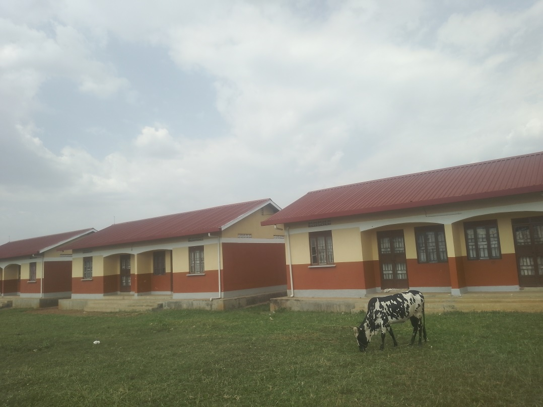
NABWEYO SSS ADMINISTRATION BLOCK | 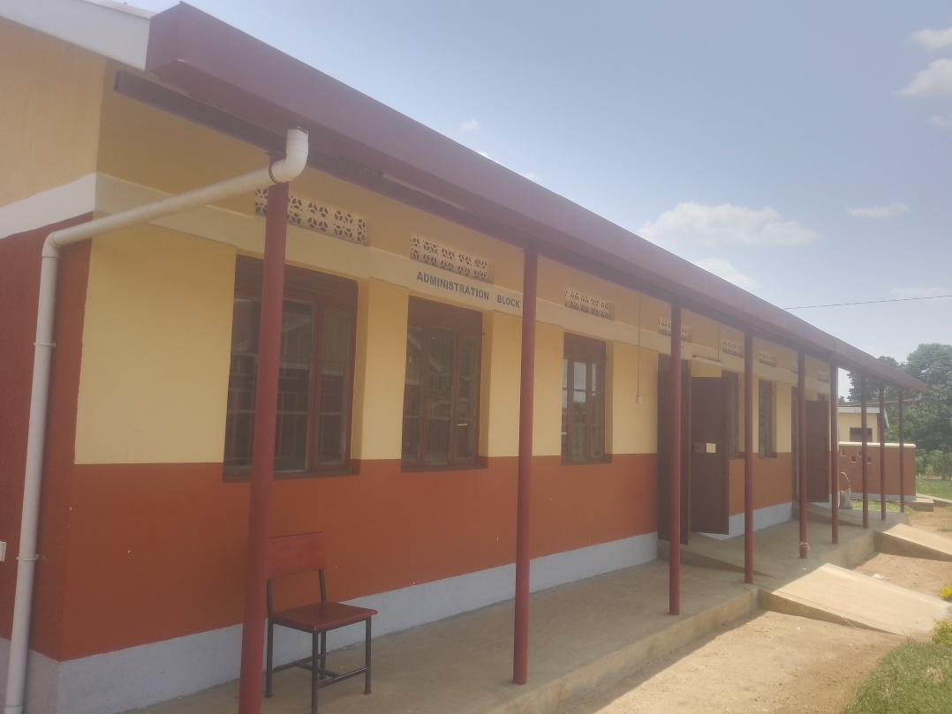
NABWEYO SSS LIBRARY | 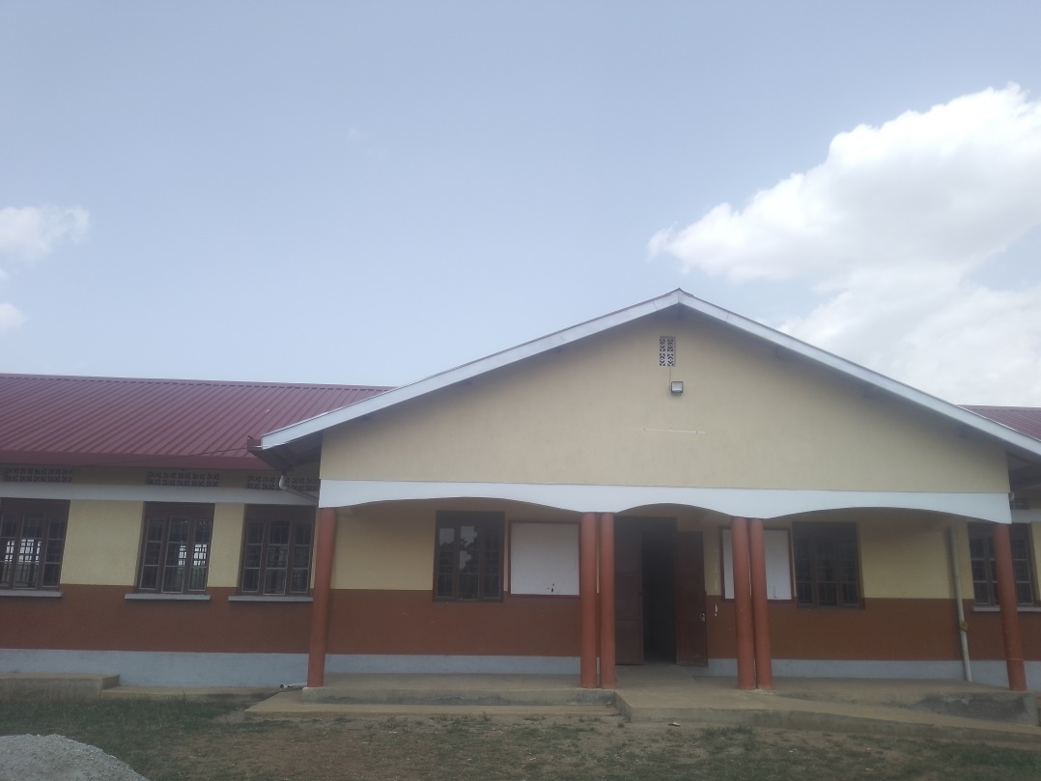
ICT /LIBRARY INTERIOR VIEW | 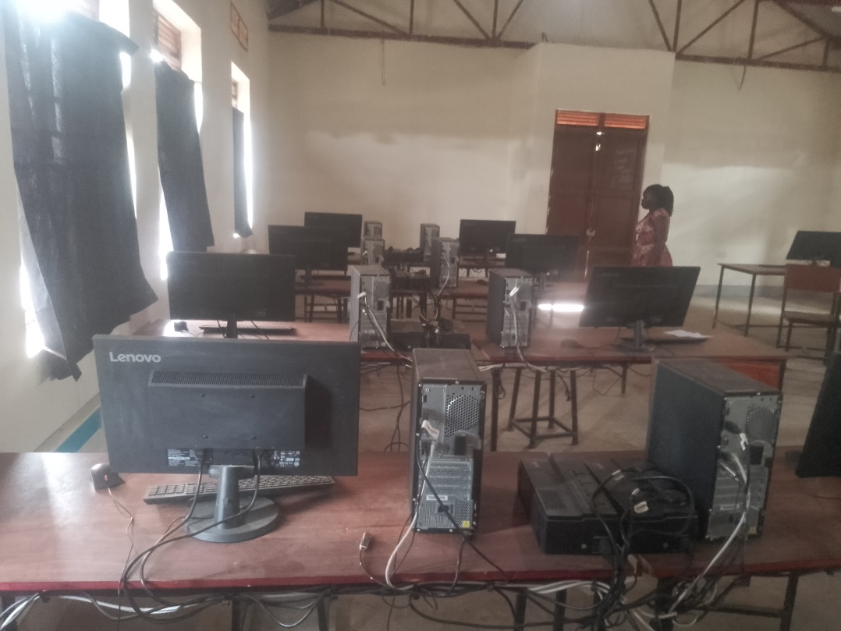
ENGRAVED  CPU  (NABWEYO SSS/O6) | 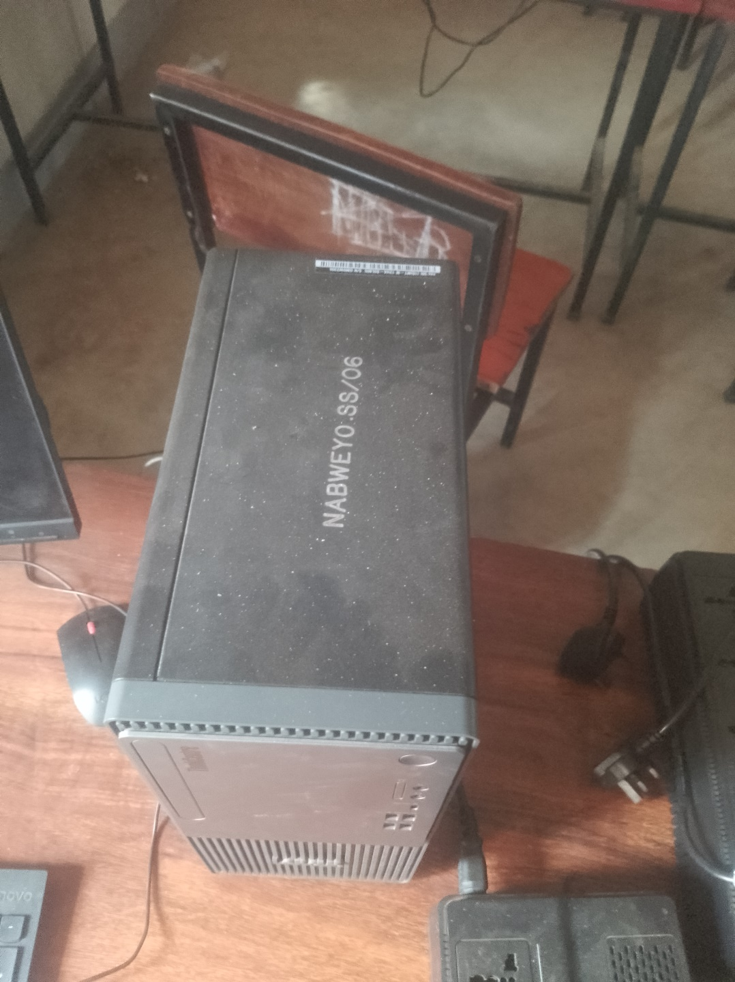
ENGRAVED KEYBOARD | 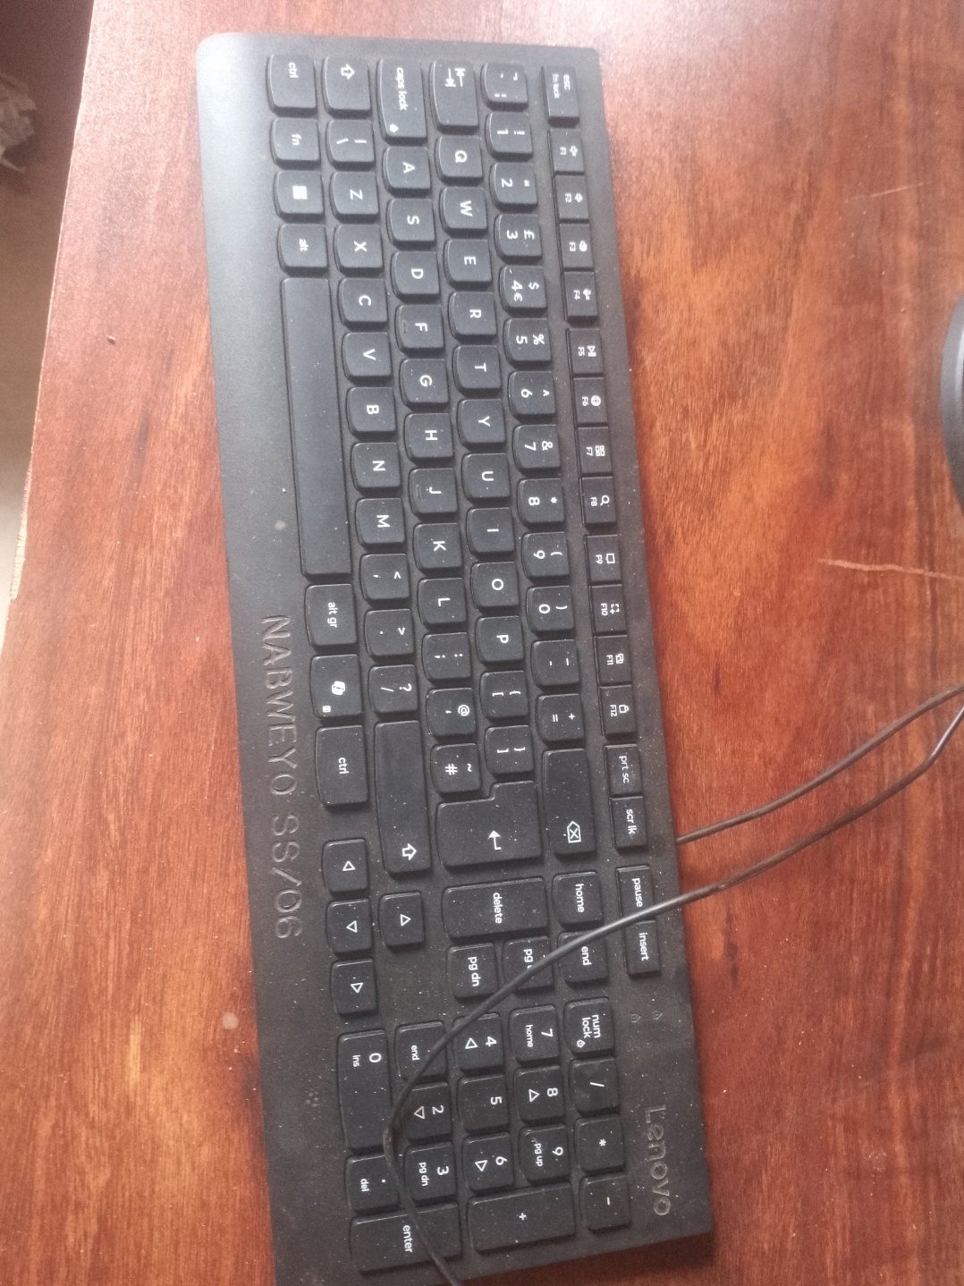
PROJECTR  NOT ENGRAVED (FAULTY) | 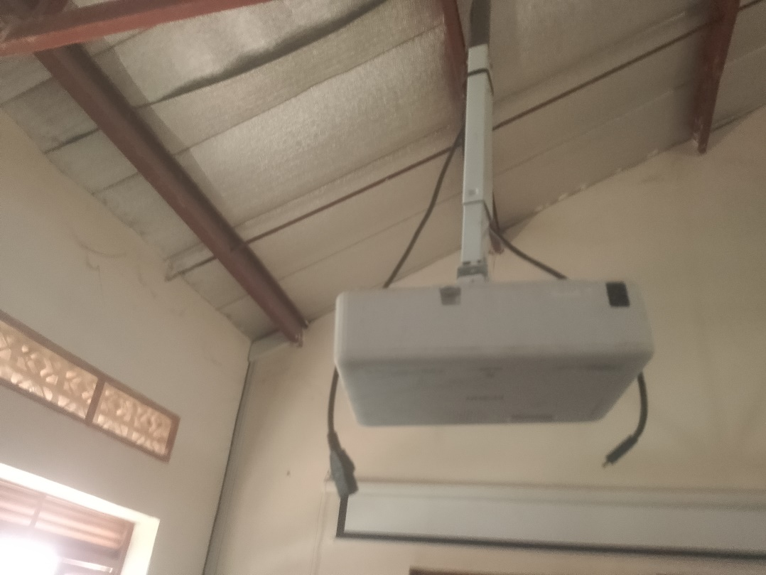
AIR CONDITIONER  NOT ENGRAVED  FUNCTIONING | 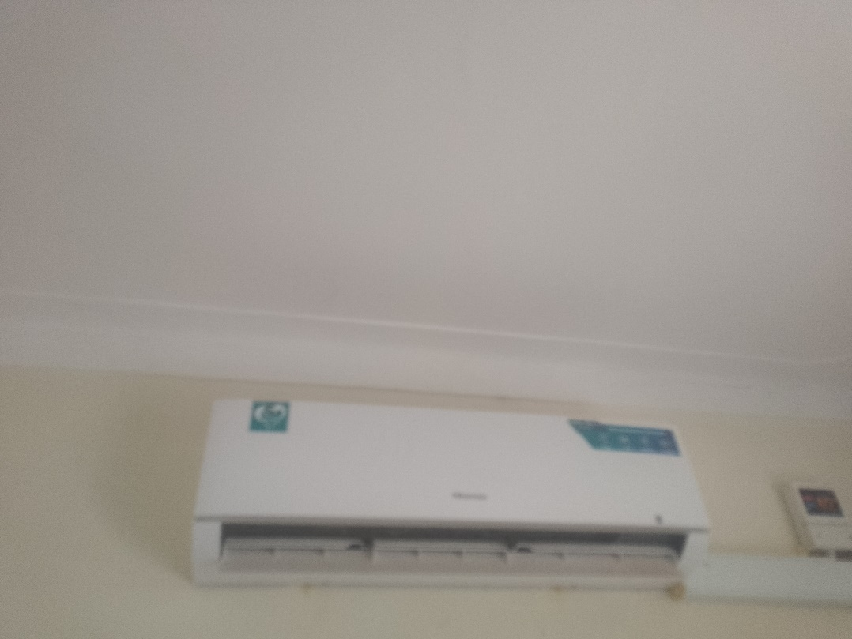
CCTV CAMERA  FUNCTIONING  FAULTY | 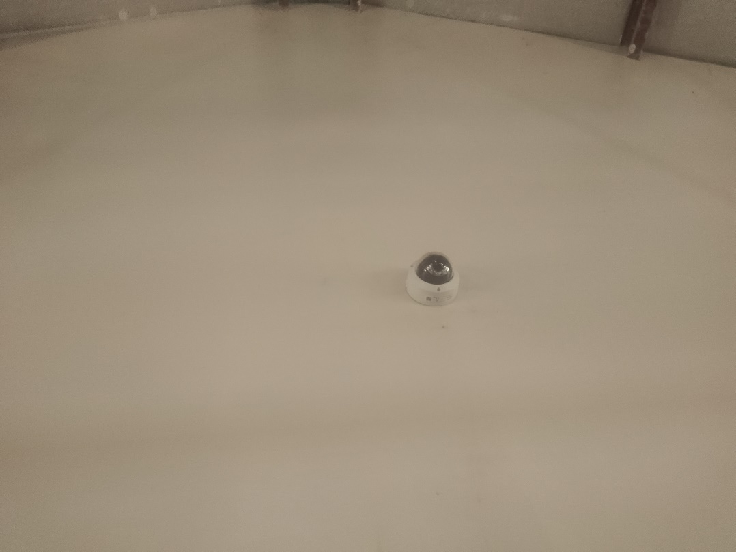
NETWORK CABINET MOUNTED ON THE WALL. NOT ENGRAVED AND FUNCTIONING | 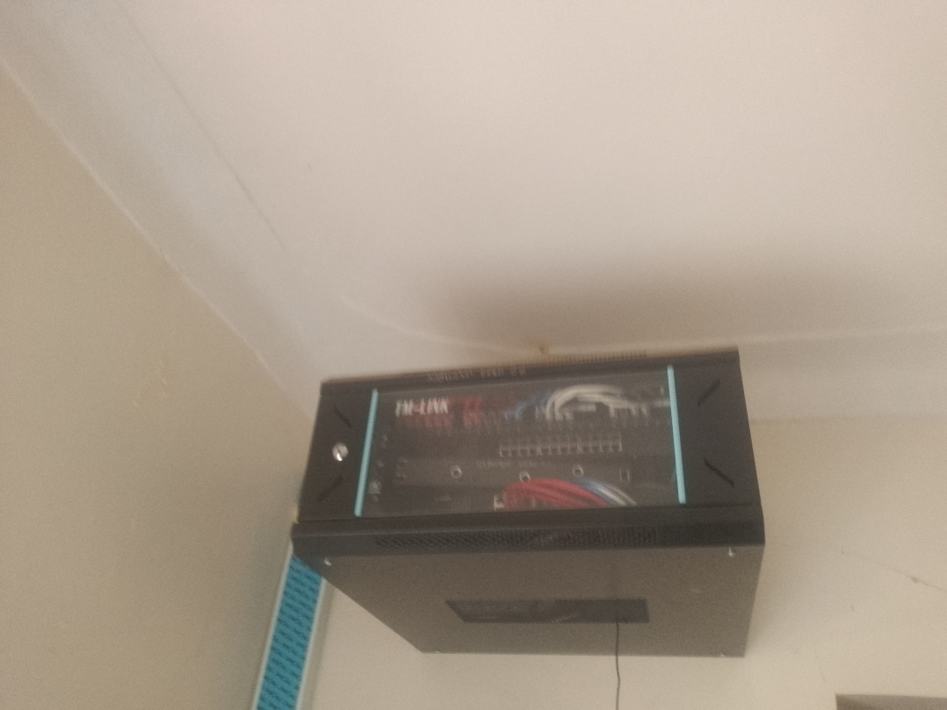
PRINTER ENGRAVED (NABWEYO SSS  FAULTY  Serial No: PHM5P18529  Product NO: 2Z609A  Regulatory Model No: SHNGC-1800-00 | 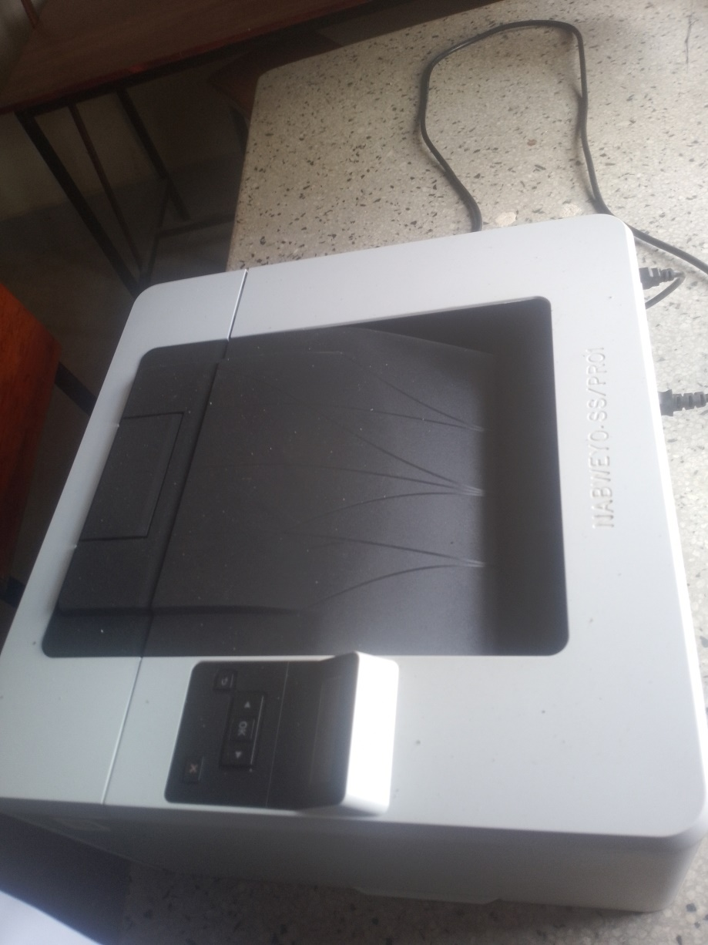
LOCKABLE WALL SHELVES | 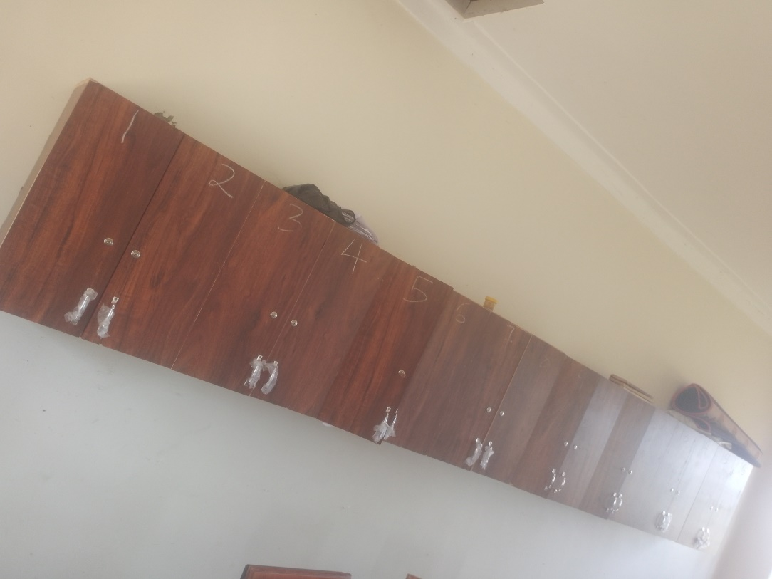
HUMAN SKELTON MODEL  IN THE LABARATORY | 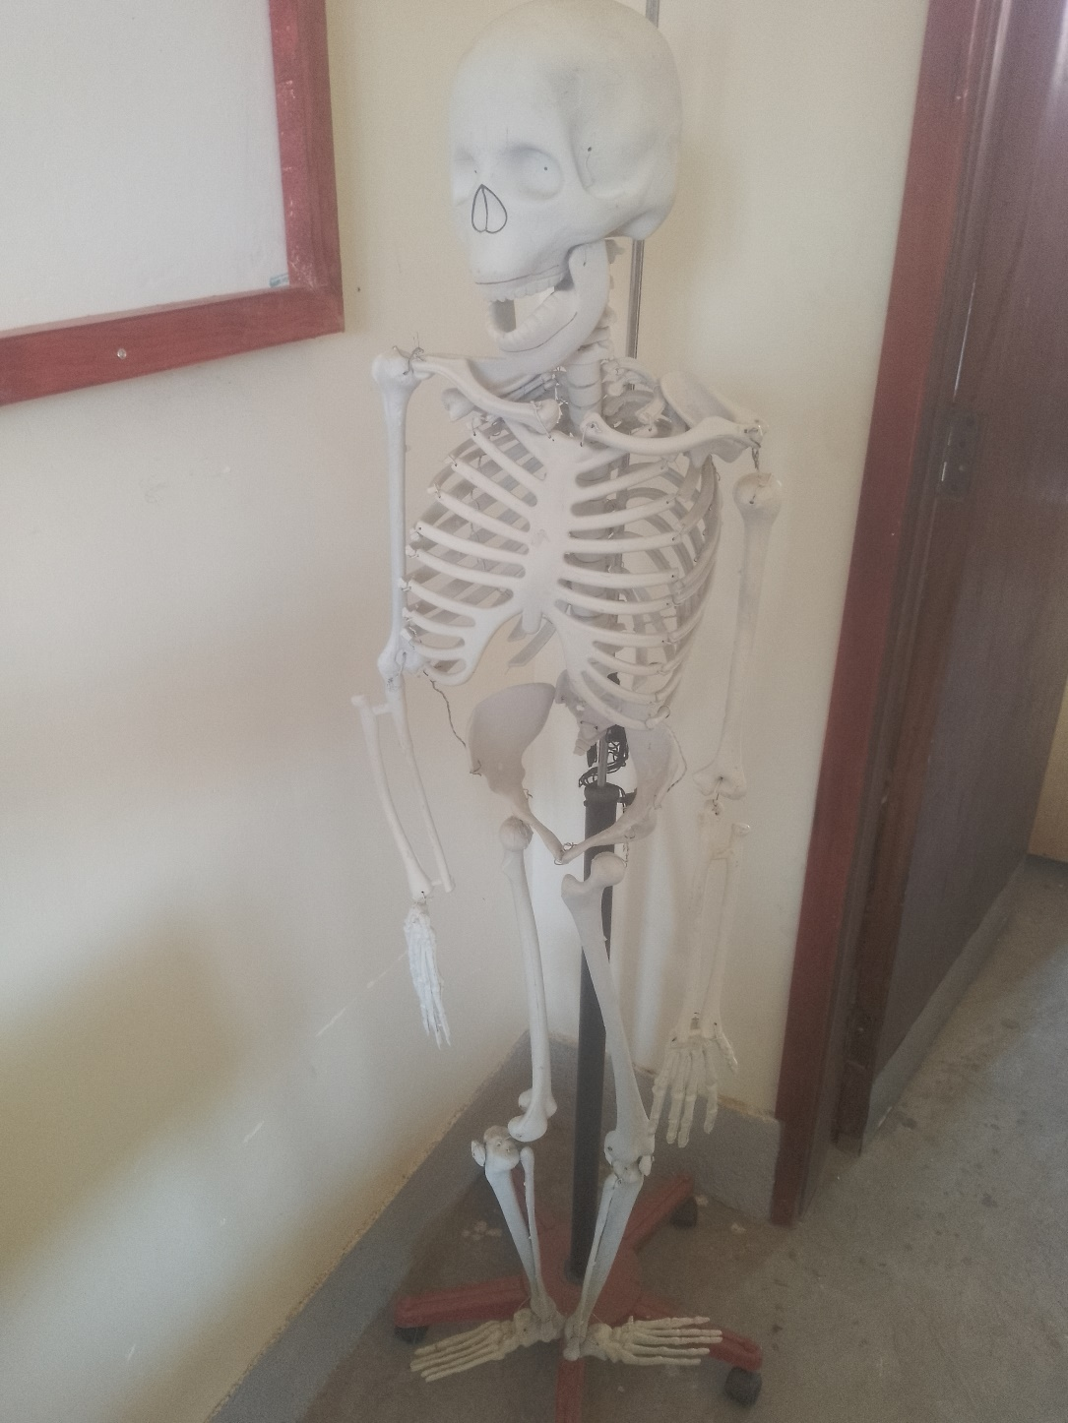
LOCKABLE CUPBOARDS IM EACH CLASSROOM  NOT ENGRAVED | 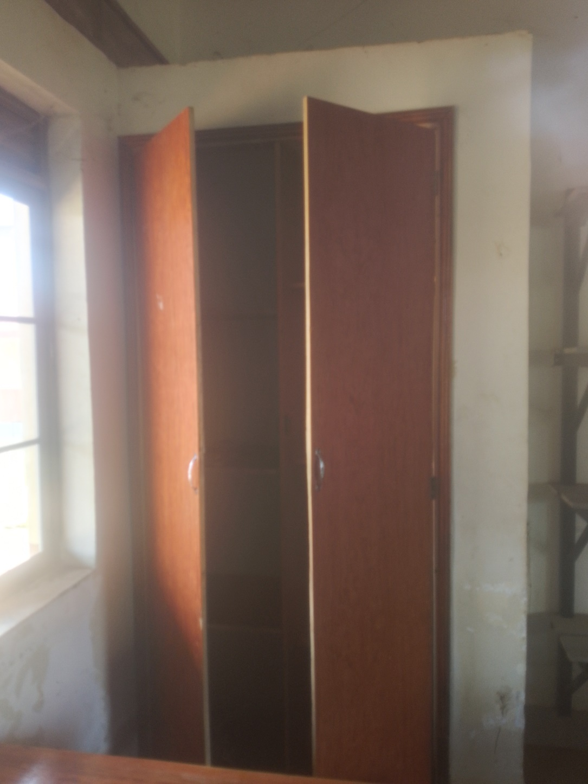
WALL MOUNTED SHELVES  PLACED IN EACH CLASS | 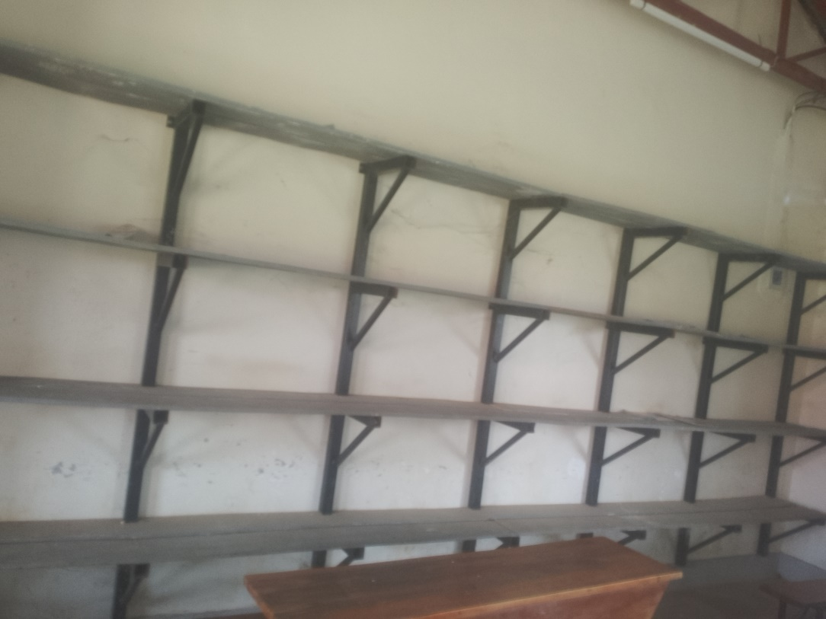
UN ENGRAVED TABLES  NOT ENGRAVED | 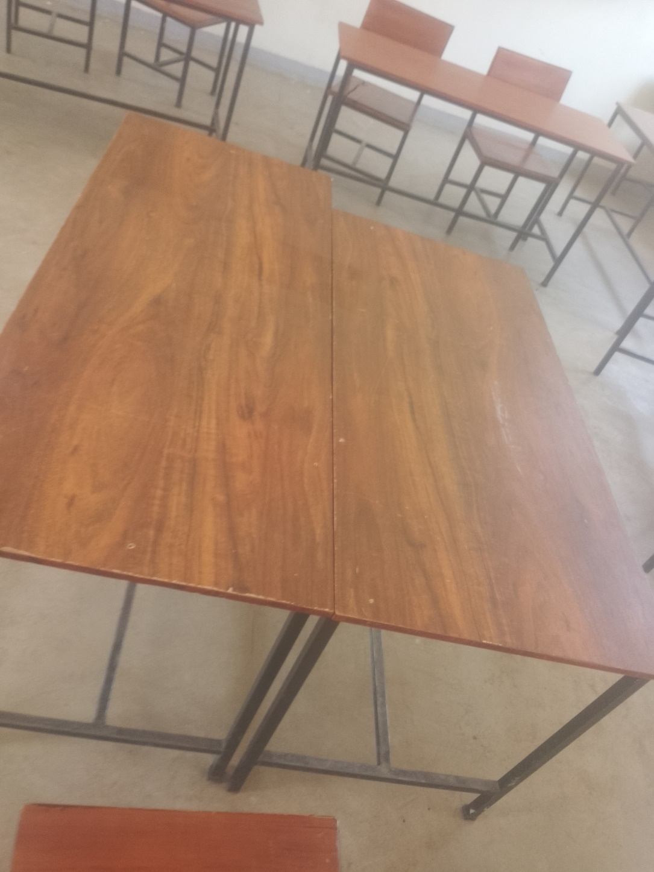
CHAIRS  NOT ENGRAVED | 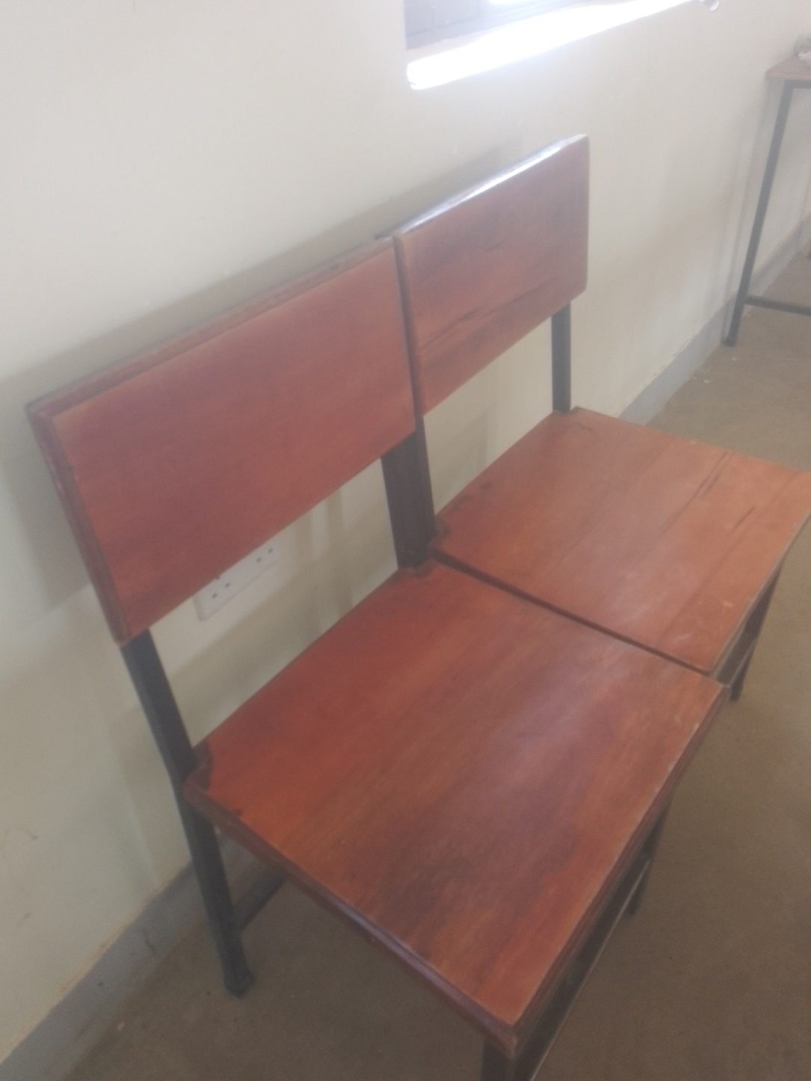
DESKS  NOT ENGRAVED | 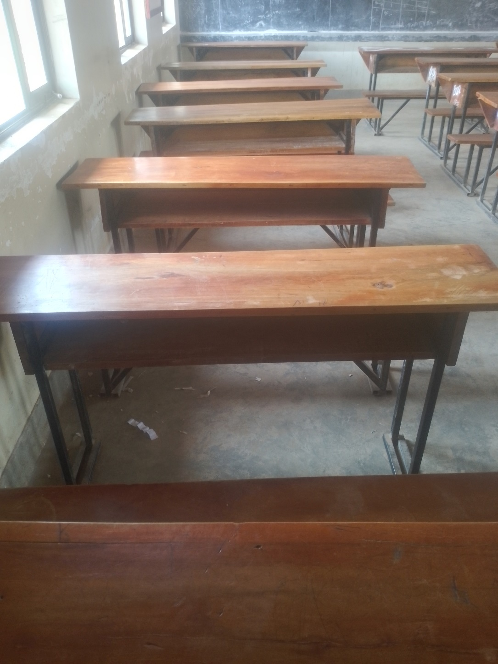
4 STANCED LATRINES | 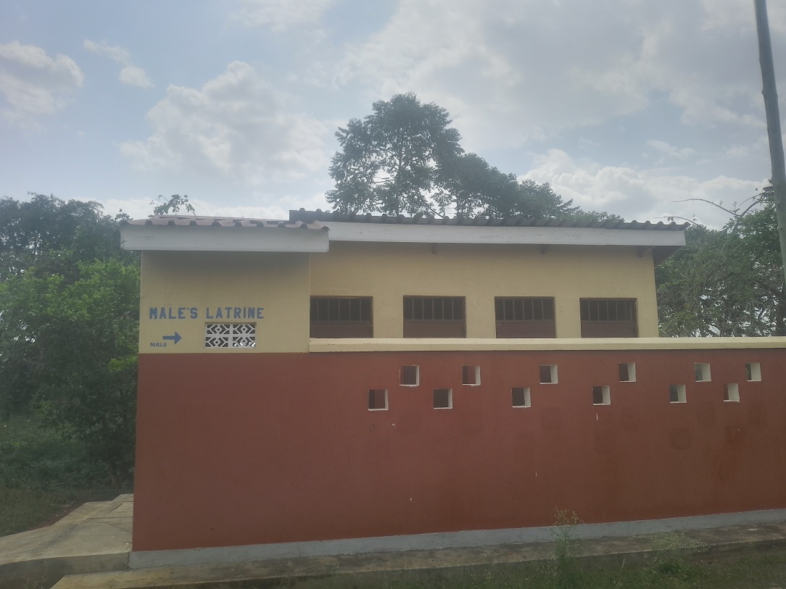
STAFF TOILETS  NOT ENGRAVED | 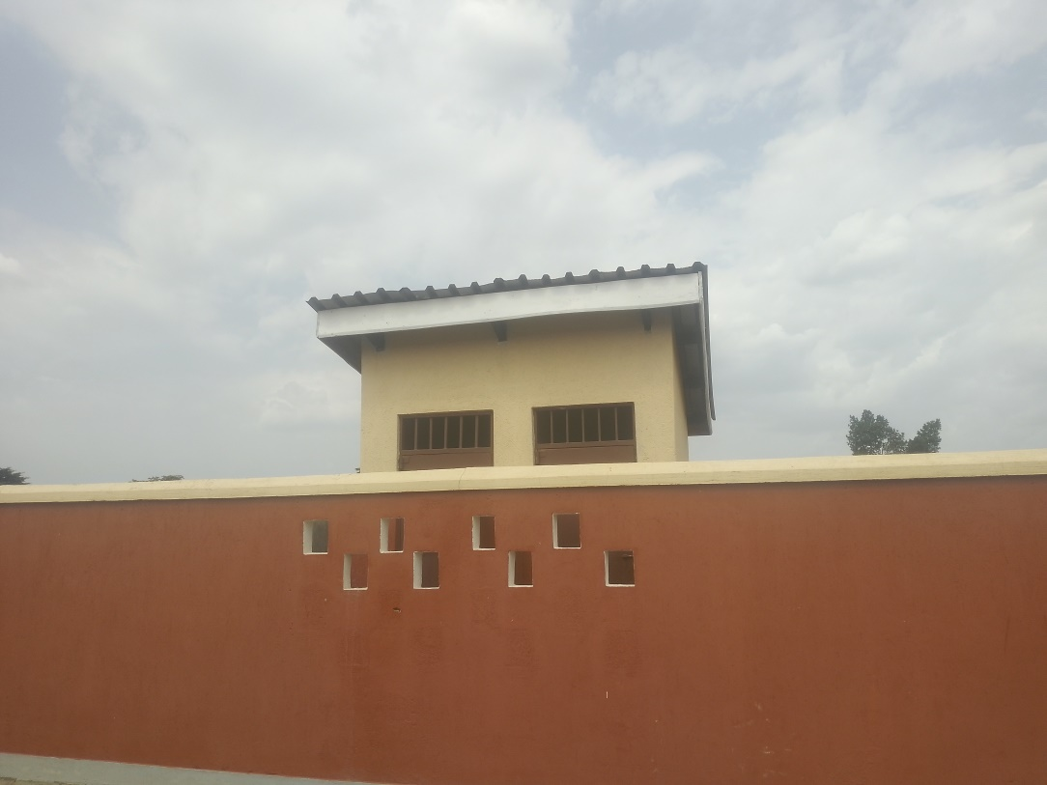
STAFFF KITCHEN  NOT ENGRAVED | 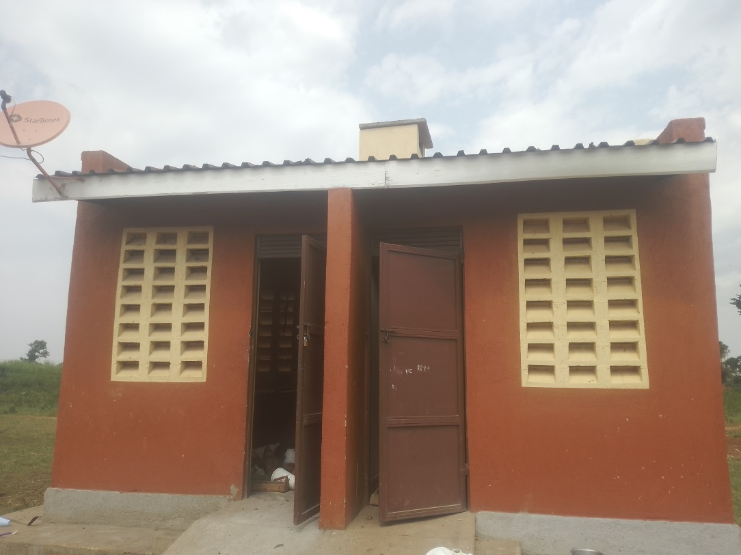
2 TANKS  (BIG 5000 LTR TANK) ON THE GROUND AND THE SMALL ONE RAISED ON METALLIC STANDS | 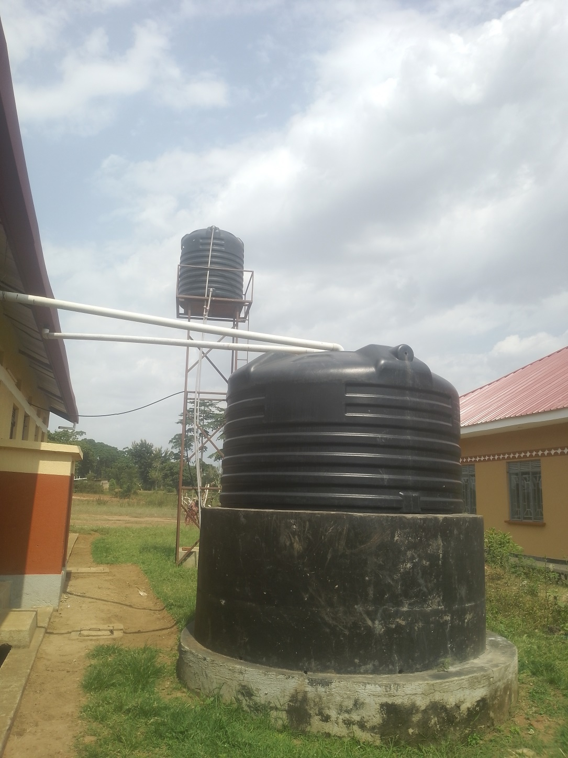
SCHOOL KITCHEN  NOT BUILT | 